# Checkmate

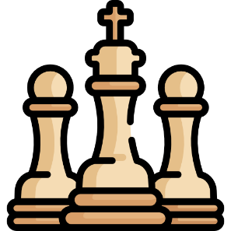

You will be given a **chess board (8x8)**. On the board there will be **3** types of **symbols**:

* **"."** – empty square
* **"Q"** – a queen
* **"K"** – the king

Your job is to find which **queens** can **capture** the king and **print them**. The moves that the queen can do is to move **diagonally**, **horizontally** and **vertically** (basically all the moves that all the **other figures** can do **except** from the **knight**). Beware that there might be queens that **stand in the way** of other queens and can **stop** them from **capturing** the king. For more clarification see the examples.

### Input

* **8 lines** – the state of the board (each square **separated by single space**)

### Output

* The **positions** of the **queens** that can **capture** the king as **lists**
* If the king **cannot be captured**, print: **"The king is safe!"**
* The **order** of output **does not matter**

### Constrains

* There will always be **exactly 8 lines**
* There will always be **exactly one King**
* Only the **3 symbols** described above **will be present** in the input

### Examples

|  |  |  |
| --- | --- | --- |
| **Input** | **Output** | **Comment** |
| . . . . . . . .  Q . . . . . . .  . K . . . Q . .  . . . Q . . . .  Q . . . Q . . .  . Q . . . . . .  . . . . . . Q .  . Q . Q . . . . | [2, 5]  [5, 1]  [1, 0] | The queens marked with green can capture the king. The queen marked with blue cannot capture the king, since the queen at [5, 1] stands in the way |
| . . . . . . . .  . . . Q . . . .  . . . . . . . .  . . . . . . . .  Q . . . Q . . .  . . K . . . . .  . . . . . . Q .  . . . Q . . . . | The king is safe! |  |

*A happy chess ending is where the King gets mated…*